**Secure It**

*Software Construction Semester Project – Description Document*

**Group Members**

Amin ur Rasheed

Mubashir Nazir

Rohma Shakeel

***Github Link:*** <https://github.com/rohmashakeel/SC-Project>

**Introduction**

This document aims to give an overview of what we have accomplished in our Software Construction Semester Project.

**Abstract**

***Background****:* Criminal activities take place in most parts of the world and they put many people’s lives in danger. In Pakistan, Many areas are deemed unsafe as they have a high criminal activity rate but not many people of the society are aware of that. People need to be provided with information related to their neighborhood and/or society to know whether or not they are safe from any kind of harm.

***Problem Statement****:* It is difficult to find out which areas have low crime rate or are safe to go to and which aren’t safe. So this is the issue that will be addressed by this end semester project.

***Solution****:* We will be designing an application that will allow people to know which areas are secure from criminal activities. The app can be used by the law enforcement agencies to update the information of many areas related to the crime rates. Even the civilians can provide the law enforcement agencies with information related to any crime that may have occurred there to make them aware of it.

***Solution Novelty****:* My solution allows the law enforcement agencies and the civilians to interact with the each other to make our surroundings safe. Civilians are provided with essential information related to the area they live in or an area where they want to go.

***Timeline of Completion:*** Requirement Elicitation: 26th march to 2nd April Design and Prototyping: 3rd April to 10th April Implementation: 11th April to 5th May Testing: 6th May to 25th May

**Design & Implementation**

The application was built for Android Platform using Android Studio for development and Firebase for implementing backend database functionality. The application consists of 4 major modules as described below.

1. Authentication Module: User authentication is done anonymously using Firebase’s API. Firebase stores a unique user id for each user without asking the user for any credentials. This is the start up activity.

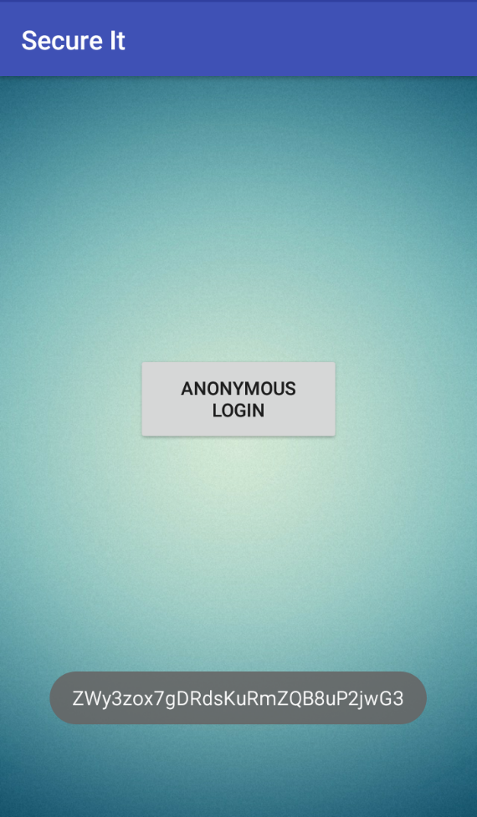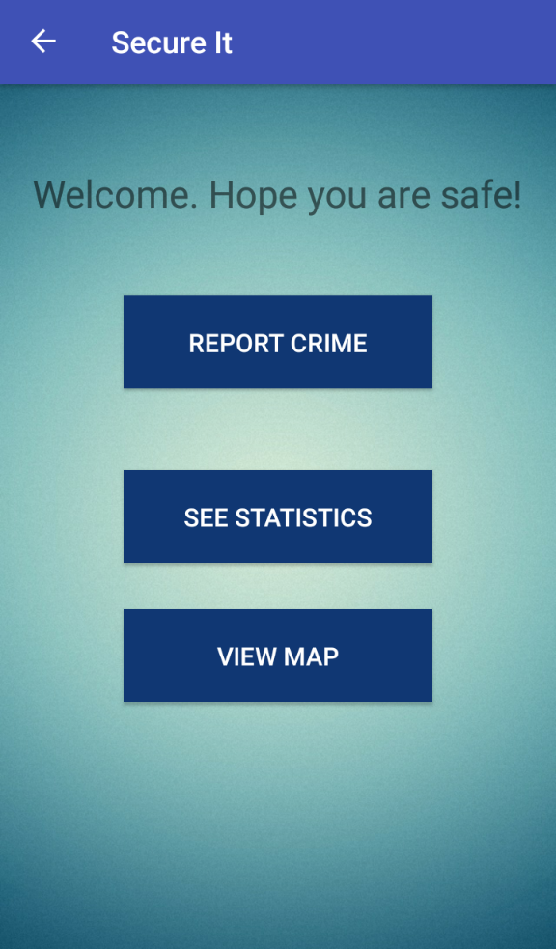

Launch Screen (Left) –

Clicking on the button logs the user anonymously into the application and a unique id is generated (shown at the bottom of picture).

The main menu screen is opened (Right).

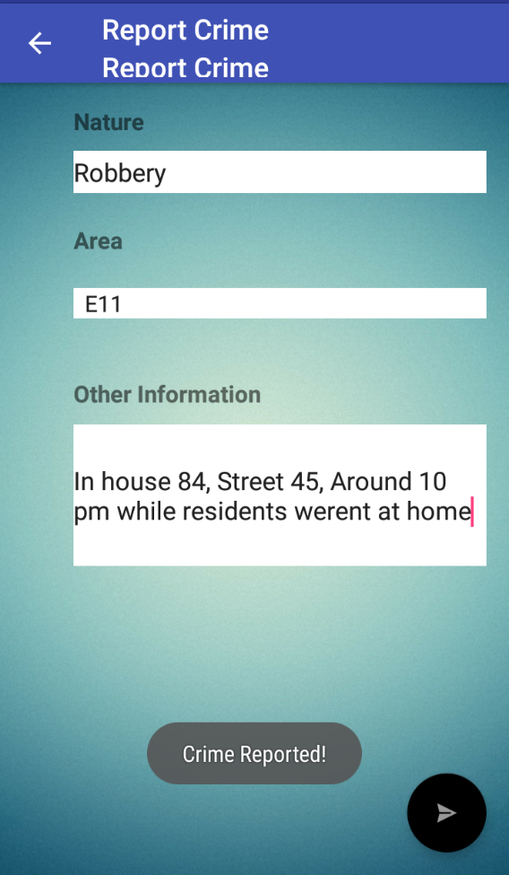

1. Report Crime Module: The second module (can be accessed through main menu screen), consists of basic crime reporting where any user can report a crime providing nature, area and any other information details. This is stored in the Firebase database which the law enforcement agencies can view/use.

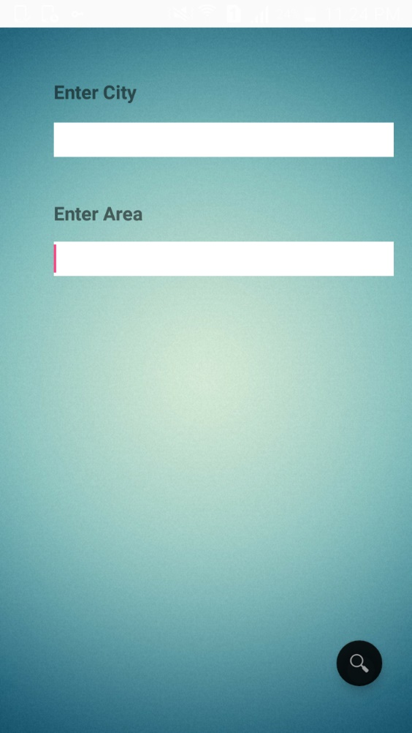

1. Statistics Module: The third module (can be accessed through main menu screen) where the user can search crime statistics in a particular area.
2. Map Module: The fourth module (can be accessed through main menu screen) gets the location of the user and shows him/her the safety ranking of the area based on the location. The safety ranking is calculated using counts of crimes obtained from the crimes reported and statistics module.

Rough Schema –

crime: id (auto gen), nature, area, other description

statistics: id (auto gen), crime type/nature, area

Rating Algo: from (count) crime with area (x) + from (count) stats.crime with area (x),

if (count >100) VERY VERY HIGH RISK

if (count 75-100) VERY HIGH RISK

if count (50-100) HIGH RISK

if count (25-50) MEDIUM RISK

if count (10-25) RISK

if count (5-10) LOW RISK

if count (<5) SAFE

Firebase Authentication Records

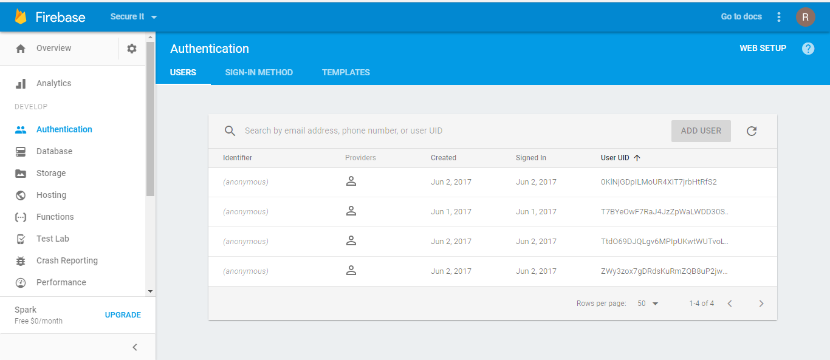

Statistics Nodes

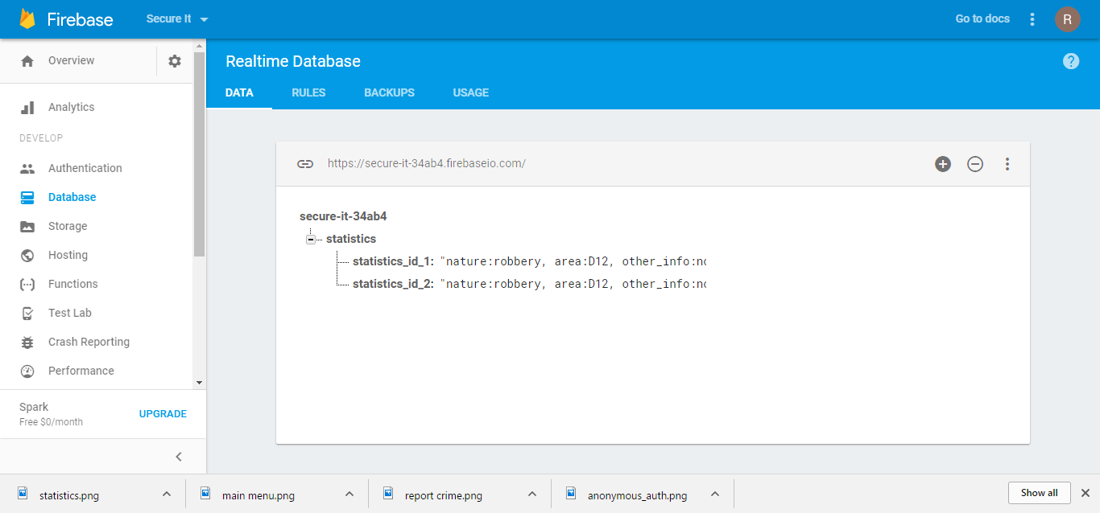

Test Lab

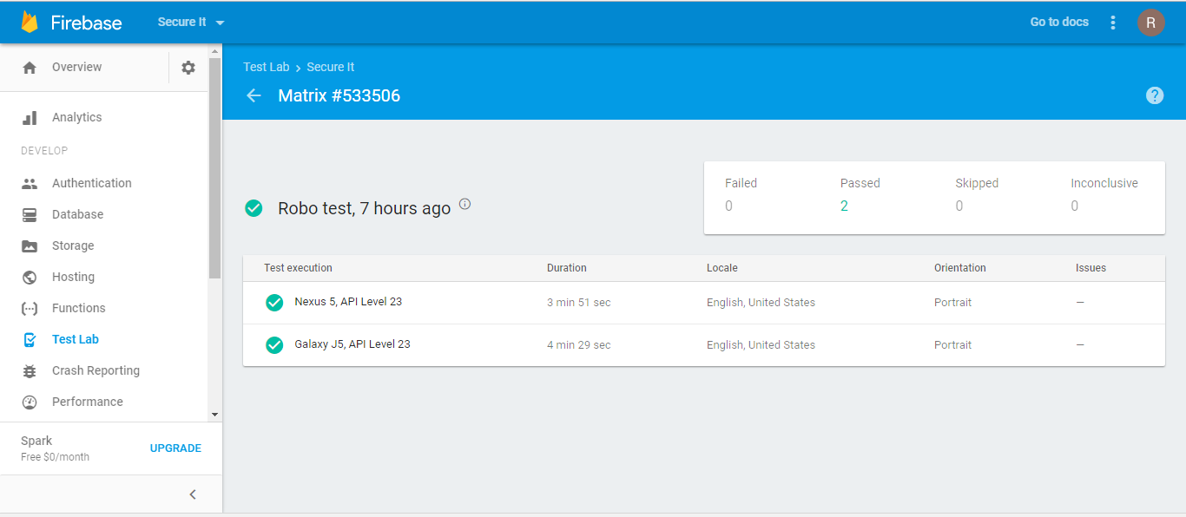

**Installation & Run Guide**

1. Download provided apk file.
2. Open file in your android smart phone and follow the inbuilt installer to install the application.
3. Open application and click Anonymously Login button to log in and access Main Menu.
4. Report Crime or View Statistics or Check Map using respective buttons.

**Results & Conclusion**

With this application we learned how to build a live application in Android Studio by integrating Firebase with it. We learned how to work with different activities, views and resources as well as using different functionalities provided by Firebase API for user authentication, saving and reading data.

We hope that our application will be beneficial for the law enforcement agencies and general public and contribute to making our community safer.